**Exercise 2: Stored Procedures (SQL Server)**

**Step 1: Create Table**

CREATE TABLE Employees (

EmployeeID INT IDENTITY(1,1) PRIMARY KEY,

FirstName VARCHAR(50),

LastName VARCHAR(50),

DepartmentID INT,

Salary DECIMAL(10,2),

JoinDate DATE

);

**Step 2: Create Insert Procedure**

CREATE PROCEDURE sp_InsertEmployee

@FirstName VARCHAR(50),

@LastName VARCHAR(50),

@DepartmentID INT,

@Salary DECIMAL(10,2),

@JoinDate DATE

AS

BEGIN

INSERT INTO Employees (FirstName, LastName, DepartmentID, Salary, JoinDate)

VALUES (@FirstName, @LastName, @DepartmentID, @Salary, @JoinDate);

END;

**Execute:**

EXEC sp_InsertEmployee @FirstName = 'Alice', @LastName = 'Smith', @DepartmentID = 2, @Salary = 60000.00, @JoinDate = '2024-05-10';

**Step 3: Create Get Employees by Department Procedure**

CREATE PROCEDURE sp_GetEmployeesByDepartment

@DepartmentID INT

AS

BEGIN

SELECT EmployeeID, FirstName, LastName, DepartmentID, Salary, JoinDate

FROM Employees

WHERE DepartmentID = @DepartmentID;

END;

**Execute:**

EXEC sp_GetEmployeesByDepartment @DepartmentID = 2;

**Output:**

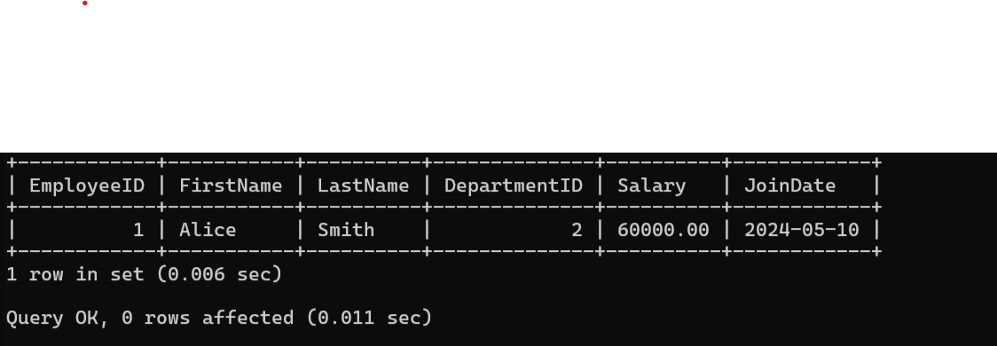

**Step 4: Count Employees by Department Procedure**

CREATE PROCEDURE sp_CountEmployeesByDepartment

@DepartmentID INT

AS

BEGIN

SELECT COUNT(*) AS TotalEmployees

FROM Employees

WHERE DepartmentID = @DepartmentID;

END;

**Execute:**

EXEC sp_CountEmployeesByDepartment @DepartmentID = 2;

**Output:**

